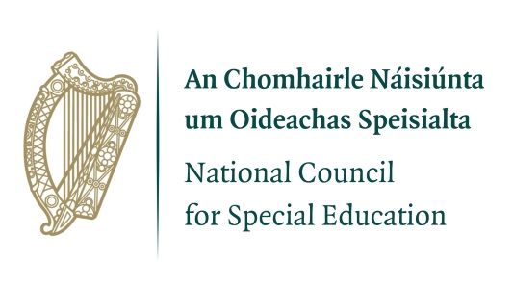

NCSE Annual Research Conference 2025
Benefits of Practitioner-Based Research and Post-School Pathways and Transitions
Wednesday 5th November 09.30-16.00hrs
Cusack Suite, Croke Park, Dublin
Time
08.30 Registration and Tea/Coffee
09.30 Welcome: Dr Fergal Lynch, NCSE Council Chairperson
09.40 Conference Address: Michael Moynihan, TD & Minister of State at the Department of Education and Youth with special responsibility for Special Education and Inclusion
09.50 Session 1: Benefits of Practitioner-Based Research
Chair: John Kearney, Chief Executive Officer, NCSE
10.00 Professor Sarah Parsons, Professor of Autism and Inclusion, Southampton Education School, University of Southampton
Building pathways to impact together: benefits and examples of close to practice research
10.30 Q&A
10.40 Examples of Practice Based Research in Irish Schools - Panel Discussion
Contributors:
Éilis Dillon, St Cecilia's Special School, Sligo
Fiona Greene, formerly Coláiste Dún Iascaigh, Tipperary
Maeve Foxton, Saint Raphaels College, Loughrea
Aisling White, Midwest School for the Deaf, Limerick
John O'Sullivan, formerly, CBS Thurles, Tipperary

11.15 Panel Discussion Q&A

11.40 Tea/Coffee

12.15 Session 2: Post-School Pathways and Transitions
Chair: Dr Peter Archer, NCSE Research Committee Chairperson

12.20 Dr Valerie L. Mazzotti, Roy A. Roberts Distinguished Professor of Special Education, Department of Special Education, Kansas University

Learnings from the USA: secondary transitions for students with special educational needs, evidence-based practices and predictors of postschool success

12.50 Q&A

13.00 Lunch

14.15 Session 2 continues: Post-School Pathways and Transitions: The Irish Perspective
Chair: Dr Peter Archer, NCSE Research Committee Chairperson

14.20 Beth Young, Associate Director of Social Policy Research at Fortia Insight, formerly RSM

Evaluation of the Comprehensive Employment Strategy Transition Pilot Programme - findings from an NCSE commissioned evaluation

14.50 Q&A

15.00 Dr Eamonn Carroll, Post-doctoral Researcher at Munster Technological University, formally ESRI and Keyu Ye, Marketing Insights Analyst at Flutter Entertainment, formally ESRI

Paths, Tracks, Gaps and Cliffs: The Post-school Transitions of Students with Special Educational Needs - findings from an NCSE commissioned study

15.30 Q&A

15.40 Thank you and conference close
Sign Language Interpretation and lunch will be provided

To submit questions during the conference please use the QR code or go to www.slido.com and enter code #NCSE2025

